**Assignment No.- 4**

**Question 1:**

Create a simple shell script to tell the user about their session – they need to know:

● What their username is

● What the current date is

● What the time is

● What their current working directory is

● How many files they have in that directory

● What is the biggest file in their current directory.

**Script:**

$Server = Read-Host -Prompt 'Input your server name'

$User = Read-Host -Prompt 'Input the user name'

$Date = Get-Date

Write-Host "You input server '$Servers' and '$User' on '$Date'"

**Question 2:**

Create a directory with a few test files in it (the files can be empty). Now write a script that for every file

in that directory you rename it to have an extension of today's date in YYYYMMDD format.

**Script:**

#!/bin/bash

DAY=$(date +%F)

Cd/home/Chaitali/testfiles

for FILE in *.txt

do

mv $FILE ${DAY} -${FILE}

done

**Question 3:**

Write a script that takes a number as an input and reverses it out to the user. For example, if the original number is 74985, the output should be 58947.

**Script:**

$numbericarray = @(1,2,4,3,6,9,7)

$numbericarray

[array]::Reverse($numbericarray)

$numbericarray

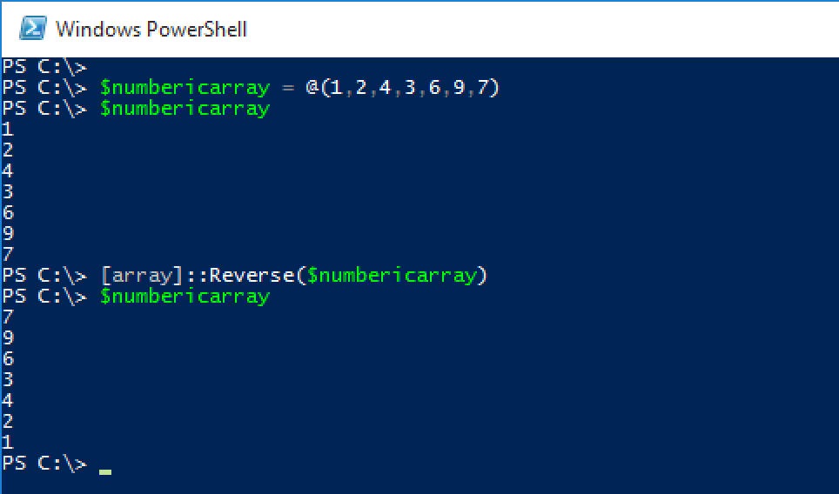

**Question 4:**

Write a script to validate how secure someone's password is. Things you would care about:

● Length should be 8 or more characters

● The password should contain numbers and letters

● There should be both uppercase and lowercase letters

**Script:**

$Input = **Read-Host** "Please enter your password. `nPassword must meet complexity requirements:

`nAt least one upper case English letter [A-Z]`nAt least one lower case English letter [a-z]`nAt least one digit [0-9]`nAt least one special character (!,@,%,^,&,$,_)`nPassword length must be 7 to 25 characters."

**if**(($input -cmatch '[a-z]') -and ($input -cmatch '[A-Z]') -and ($input -match '\d') -and ($input.length -match '^([7-9]|[1][0-9]|[2][0-5])$') -and ($input -match '!|@|#|%|^|&|$|_'))

{

    Write-Output "$input is valid password"

}

**else**

{

    Write-Output "$input is Invalid paasword"

}